Remotely-Controlled Catapult
January 2019

CNT 4104 Software Project in Computer Networks
Instructor: Dr. Janusz Zalewski
Department of Software Engineering
Florida Gulf Coast University
Ft. Myers, FL 33965

Copyright © 2019 by Florida Gulf Coast University

1. Introduction

The objective of this project is to apply the fundamentals of an embedded system to remotely control a catapult, launching small-scale projectiles via an Android device. The catapult project will fulfill a need to effectively reduce user intervention, such that the user won’t have to manually retract or lock the catapult arm into place but will only be required to reload the device. This project is based upon an idea that has been accomplished on numerous occasions, in various ways.
While researching catapult projects, some common features of each catapult included push-button operation as well as separate servos designated for angle, tension, and as a locking mechanism [1]. The structure and the method of providing tension to the catapult differed in every scenario, ranging from rubber bands, springs, and even strings, but the basic principle was the same. However, there was one feature that each of the catapult projects didn’t take into account, which this project intends to expand upon: remote-control of the device over a network. Therefore, this project is an innovative way of expanding the existing solutions.
The project will be implemented using a few technologies communicating via the network. An Android application will be used to communicate with an Arduino UNO REV3 [2] board attached to the catapult. For the Android application, the project will use MIT App Inventor [3], which is a mobile GUI builder that will allow the Android device to interface with the Arduino hardware and will be vital to the project’s success as an Internet of Things (IoT) device. The Android application will offer several methods of input: lock the catapult arm into place, tension the catapult arm, and fire the projectile. A series of micro-servos [4] will be used to perform functions such as locking, releasing, and providing tension to the catapult arm. A 6V/2A Power Supply [5] will be connected to the device, to provide optimal current and voltage to the Arduino board. The micro-servos will rely on a sensor shield, to resolve underpowered servos (limited by the Arduino’s built-in 5V regulator), so that the servos may reach their full range of rotation under peak load. As for the device’s connectivity, in order to enable short-distance, networked communication between the Arduino board and the Android application, a HC-05 Bluetooth Module [6] will be integrated with the Arduino board. The interactions between each of these components is defined in the following section ‘Software Requirements Specification’.

2. Software Requirements Specification

The ultimate goal of this project is to complete a functional model that is both traceable (satisfies the requirements denoted in the Software Requirements Specification) and follows the essential characteristics of an embedded system. As mentioned in the Introduction, this project uses previous findings as a foundation and expands upon it (while emphasizing on a networked device). Depicted in Figure 2.1 is the Physical Diagram, which models the catapult’s interaction with each entity in the system. The operation is started by a human operator or user, who interacts with the Android application to interface with the device. The user may either press the ‘Arm’ or ‘Launch’ button, which communicates with the Arduino over the network to provide rotational input to each of the micro-servos. If the ‘Arm’ button is pressed by the operator, one of the micro-servos will lock the catapult arm into place and the other will provide tension to the catapult arm. If the ‘Launch’ button is pressed, the micro-servo holding the catapult arm in the launch position will be unlocked, releasing the accumulated kinetic energy contained in the catapult arm, and firing the projectile. Following a brief delay after the launch, the other micro-servo will relieve the catapult arm of the provided tension so that it falls to the rest position. Once either mode has been activated, MIT App Inventor will store the button status information, corresponding to the mode that is currently active. This button status information will be passed to the Arduino so that it may rotate the lock/tension servos at fixed degree intervals; the interval length will depend on if the button state is equivalent to ‘Arm/Launch’. After the projectile has been armed or launched, the catapult checks the serial connection status to know if it is authorized to continue operation (listen for new button presses).
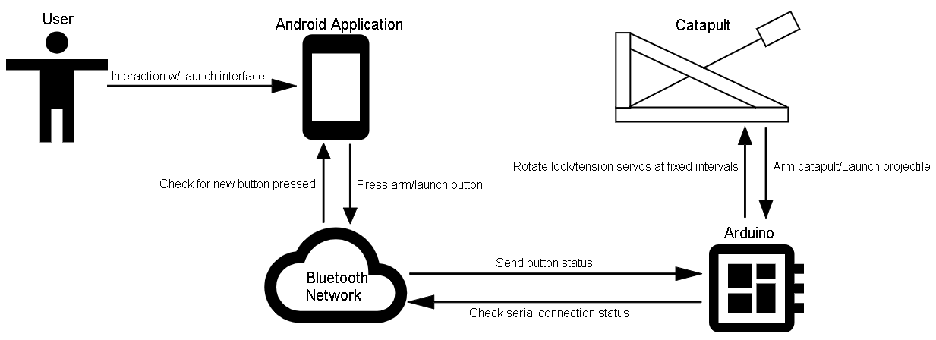
Figure 2.1: Physical Diagram
Figure 2.2 shows the project’s Context Diagram, which represents the interactions of the software with the environment. The Android Software will be installed on the Android device, which will allow the user to ‘Arm’ the catapult (lock the catapult arm into place and apply tension) and ‘Launch’ the catapult (release the locking mechanism). In doing so, the Android Software sends button states to the Arduino Software over the network via a HC-05 Bluetooth Module, so the Android Software must be in possession of a Personal Identifier Number (PIN). Button states received by the Arduino Software will determine the behavior exhibited by each micro-servo, which will be translated into Pulse Width Modification (PWM) output signals and sent from the Arduino pins (either digital or analog pins will suffice). The PWM output signals will then be used to rotate each of the micro-servos to their determined positions. The rotation range for each micro-servo will vary depending on the servo’s purpose and gear-ratio. Once the catapult has been armed or has launched the projectile, the Arduino Software will check the current status of the serial connection to see if it is appropriate to continue reading button input.
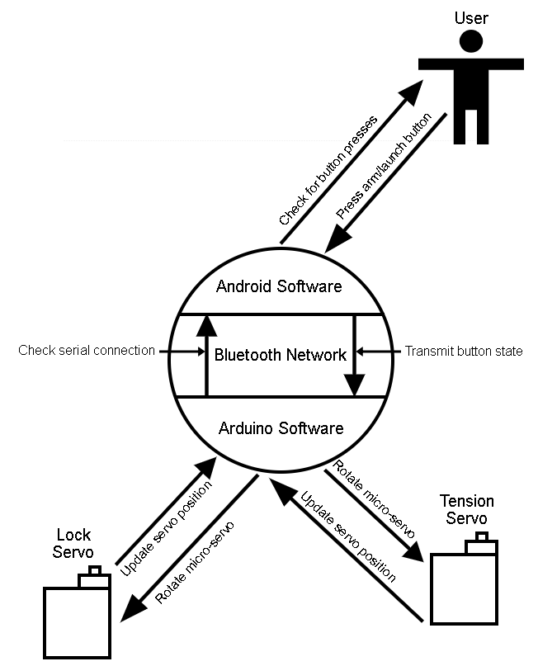
Figure 2.2: Context Diagram for Software
The software requirements are formulated as follows:
Android Software Requirements
1.1: The Android Software shall allow the user to interface with the catapult to launch projectiles via the ‘Launch’ button.
1.2: The Android Software shall send status information to the Arduino Software, following the launch of the catapult.
1.3: The Android Software shall prompt the user with a push notification when the catapult has been launched and is ready to be re-armed.
1.4: The Android Software shall allow the user to interface with the catapult to lock the catapult into place and tension it via the ‘Arm’ button.
1.5: The Android Software shall send status information to the Arduino Software, following the arming of the catapult.
1.6: The Android Software shall prompt the user with a push notification when the catapult has been armed and is ready to launch.
1.7: The Android Software shall not permit proper operation when the Android device is disconnected from a Bluetooth device.
1.8: If the Android device is disconnected from a Bluetooth device, the Android Software shall prompt the user with a status message stating that the device is disconnected.
1.9: The Android Software shall allow the user to scan for and select from a list of Bluetooth devices to connect to.
1.10: If the Android device is connected to a Bluetooth device, the Android Software shall prompt the user with a status message stating that the device is connected.
1.11: The Android Software must require a Personal Identifier Number (PIN) to pair with the Bluetooth module.
Arduino Software Requirements
2.1: The Arduino Software shall execute motor commands, which will send PWM output signals to rotate each micro-servo.
2.2: The Arduino Software shall interact with a micro-servo to lock/release the tension stored within the catapult arm.
2.3: The Arduino Software shall interact with a micro-servo to add and remove tension from the catapult arm.
2.4: The Arduino Software shall be able to handle status information, received from the Android Software.
Design Constraints
3.1: The Bluetooth module shall allow secure, short-distance network communication between the Arduino Software and the Android device.

3. Design Description

Software Architecture
Pictured in Figure 3.1 is the Software Architecture, which is derived from and consistent with the Context Diagram and models the interactions between the device’s software components and the external world. The operation initiates with a user-controlled Android device, on which the Android Software (MIT App Inventor application) will be installed. MIT App Inventor will be used as the device’s GUI builder, which will allow the Android device to interact with the Arduino hardware across the network. MIT App Inventor uses a concept called blocks, which are visual representations of typical programming constructs such as events, methods, and properties used to control software behavior. In this case, the MIT application will use button presses, which will provide input to the Arduino Software in the form of button state changes and will specify actions taken on the hardware end. In order for the user to establish a connection with the HC-05 Bluetooth Module, the Android Software, Arduino Software, and HC-05 Bluetooth Module must be interconnected via Bluetooth serial connection over the network. Once they are connected, the Android Software will be able to send input to the Arduino Software, and the Arduino Software will translate the input into PWM output signals that will be used to rotate the micro-servos. The Arduino Software will utilize libraries specifically suited for establishing serial connection with the HC-05 Bluetooth Module and controlling servo input, including Servo.h and SoftwareSerial.h.
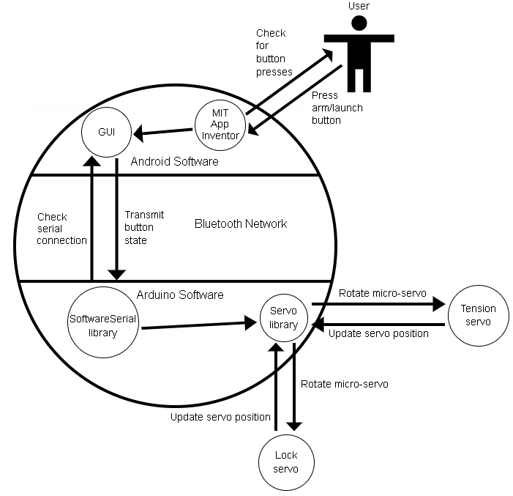
Figure 3.1: Software Architecture Diagram

Detailed Design - Static Perspective
The pseudocode in Figure 3.2 outlines the static perspective or the details of the Arduino Software’s structure. The Arduino Software will use a SoftwareSerial object to connect to the HC-05 Bluetooth Module by replicating the functionality of Arduino serialization ports TX and RX. Within the setup() function, the Arduino Software will begin serial communication with a baud rate of 9600 and assign pin drivers for each of the micro-servos. In the loop() function, once the program has established a serial connection with the HC-05 Bluetooth Module, it may provide input to the micro-servos using a Graphical User-Interface (GUI) built with MIT App Inventor. By default, the initial position of the lock servo will be 90° and the tension servo will be 0°. The rotational input provided to each of the servos will vary depending on the button pressed. If the ‘Arm’ button is pressed (button state is equal to “arm”), the lock servo will rotate to 0° and the tension servo will rotate to 180°, locking the catapult arm into place and tensioning it. When the ‘Launch’ button is pressed (button state is equal to “launch”), the lock servo will rotate back to 90°, releasing the catapult arm from its rest position. Then, after a brief delay (so that the catapult doesn’t lose tension while it is in the process of launching), the tension servo will return to its initial position of 0° as well.

// Include libraries for serialization and servos
// Declare SoftwareSerial object for serial communication
// Declare Servo objects for lock and tension

setup() function
// Begin serial communication with a baud rate of 38400
// Attach pin as a servo driver for lock servo
// Attach pin as a servo driver for tension servo
// Set initial position of lock servo to 90°
// Set initial position of lock servo to 0°

loop() function
if (serial connection is available)
while (serial connection is available)
// receive button state from serial connection
if (button state is equal to “arm”)
// Set the angle of the lock servo to 0°
// Set the angle of the tension servo to 180°
else (button state is equal to “launch”)
// Set the angle of the lock servo to 90°
// Brief delay before next servo command
// Set the angle of the tension servo to 0°

Figure 3.2: Pseudocode for the Arduino Software

The pseudocode in Figure 3.3 outlines the static perspective or the details of the Android Software’s structure. Using MIT App Inventor, the pseudocode will be composed of logical blocks, to provide functionality to the GUI Design. To do so, two non-visible components will have to be imported: the Bluetooth Client and the Notifier. To connect the Android device to the Bluetooth Client, a ListView called ‘Scan’ will be selected, which will populate a list with Bluetooth devices and each of their addresses. A Bluetooth device will be chosen from the list, which will pair the Bluetooth device with the Android device and change the connection status to “Connected”. The chosen Bluetooth device may be disconnected by pressing the ‘Disconnect’ button, which will change the connection status to “Not Connected”. Provided the Android device is connected to the Bluetooth Client, the Android Software may toggle between two different modes implemented with one button: ‘Launch’ and ‘Arm’. Prior to toggling, “Arm” will be set as the initial button text by default. When the ‘Arm’ button is toggled, it will send the button state “arm” to the Arduino Software via serialization and overwrite the button text with “Launch”. On the contrary, when the ‘Launch’ button is toggled, it will send the button state “launch” to the Arduino Software via serialization and overwrite the button text with “Arm”.

// Import non-visible components: Bluetooth Client and Notifier

// Setup buttons for connecting a Bluetooth device
// Prior to picking "Scan" list view
// set elements of "Scan" button to list of Bluetooth devices
// After picking "Scan" list view
// connect the Android device to Bluetooth device selected
// change connection status to connected
if (Disconnect" button is clicked)
// disconnect the Android device from Bluetooth device selected
// change connection status to disconnected

// Single button operation for arming/launching the catapult
if (button is clicked)
// set button text to "Arm" by default
// check device connection with Bluetooth Client
if (device is connected to Bluetooth Client)
// check current button text
if (button text is equivalent to "Arm")
// Send button state "arm" to Arduino Software via // serialization
// Set button text to "Launch"
// Notify that the catapult is armed and ready to launch
if (button text is equivalent to "Launch")
// Send button state "launch" to Arduino Software via // serialization
// Set button text to "Arm"
// Notify that a launch has occurred, re-arm required
if (device is not connected to Bluetooth Client)
// do nothing

Figure 3.3: Pseudocode for the Android Software

Detailed Design - Dynamic Perspective
Figure 3.4 represents the flowchart, which models the software behavior or the dynamic perspective for the Arduino software. The operation begins with establishing a serial connection between the Arduino hardware and the HC-05 Bluetooth Module. The user interfaces with the GUI generated with the MIT App Inventor application and stores the button state as input. Once the button state has been stored, the software must make a decision to determine whether the ‘Arm’ button or the ‘Launch’ button has been pressed. If the ‘Arm’ button was pressed, the catapult arm will be locked into place and tensioned. If the ‘Launch’ button was pressed, the locking mechanism will be released, and allow for a brief delay to pass so that the remaining tension is released from the catapult arm. Then the tensioner will default to its initial position, so that the catapult arm may free-fall back to the launch position. After either the ‘Arm’ button or the ‘Launch’ button has been pressed, the software will send a push notification (specific to the task performed) back to the user. There is no end process for this flowchart because the software continually listens for user input in the form of button clicks unless the hardware is reset.

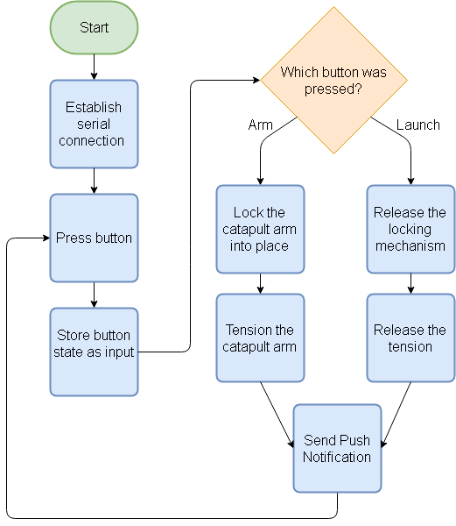
Figure 3.4: Flowchart for Arduino Software

GUI Design
Depicted in Figures 3.5 - 3.8 are mockups of the GUI that will be used by the Android device to interface with the Arduino Software, which will in turn interact with the catapult hardware. The layout and content of the GUI design is relatively primitive, with one list viewer and two buttons designated for connecting the Android device to the HC-05 Bluetooth Module, arming the catapult (locking the catapult arm into place and applying tension), and launching the catapult (releasing the locking mechanism). Following the arming of the catapult, the MIT App Inventor application will use push notifications to inform the user that the catapult is armed and ready to launch (Figure 3.7). Once the catapult has been launched, the MIT App Inventor application will notify the user that a launch has occurred and that a re-arm is required (Figure 3.8). The MIT App Inventor application will also relay error notifications to the user when the device is offline (disconnected from the HC-05 Bluetooth Module).
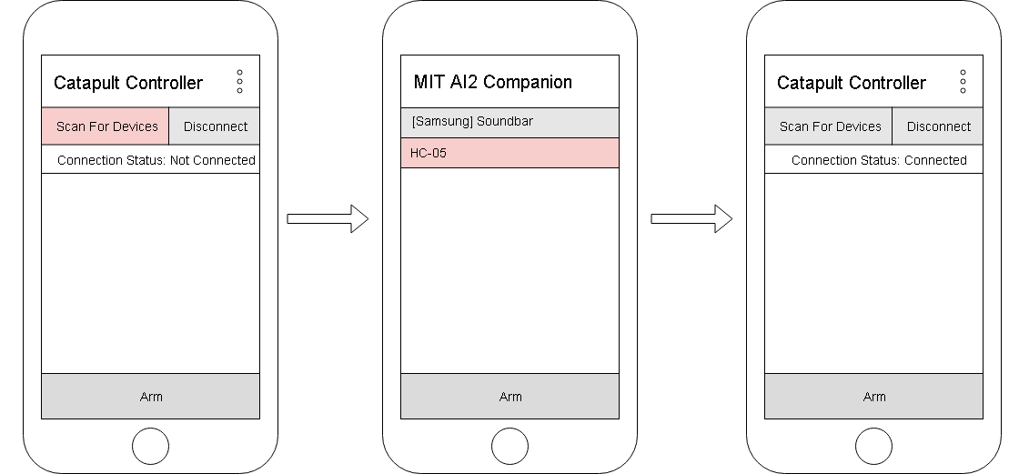
Figure 3.5: GUI for ‘Scan’ Button
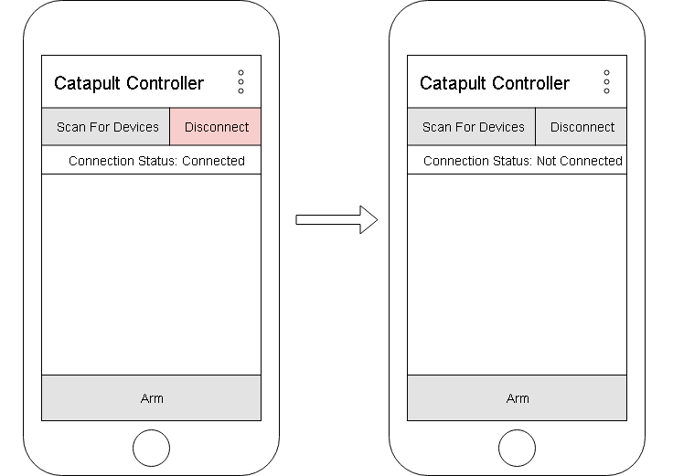
Figure 3.6: GUI for ‘Disconnect’ Button

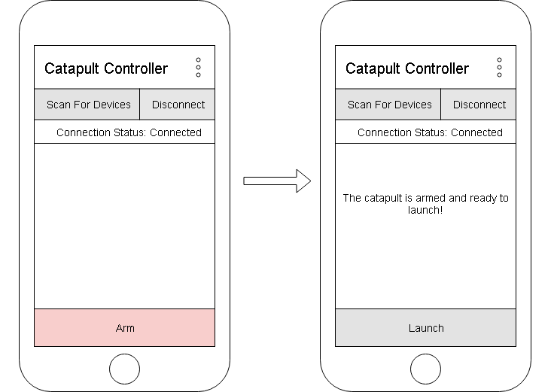
Figure 3.7: GUI for ‘Arm’ Button
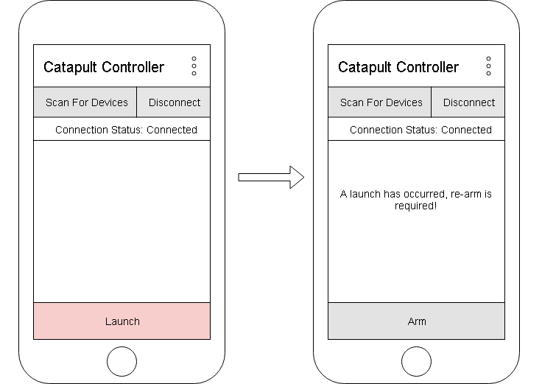
Figure 3.8: GUI for ‘Launch’ Button

4. Implementation and Testing

4.1. Assembly and Coding
For the general assembly of the remote-controlled catapult device, the electronics parts will consist of an Arduino UNO REV3, a RobotGeek Sensor Shield (V2), two FS90MG Micro Metal Gear Servos (packaged with servo horns and set screws), an HC-05 Bluetooth Transmission Module, a Full Sized Breadboard, a 6V Power Supply, four Female/Male Jumper Wires of colors red, black, blue, and green (any length jumper wires will suffice), a 1K Ohm ¼ Watt PTH resistor, and a 2.2K Ohm ¼ Watt Carbon Film Resistor. The RobotGeek Sensor Shield is compatible with any Arduino board, so the Sensor Shield male header pins should fit perfectly with the female header pins of the Arduino UNO REV3, just make sure that the male header pins aren’t bent when exerting force down on the Sensor Shield to attach it to the Arduino board. Conveniently, the Sensor Shield converts the Arduino’s Digital IO pins into 3-pin adapters, so that it is easier to add servos and other sensors to the project. Under the group of pins labeled Voltage In (VIN), attach one servo to DIO-10 and the other to DIO-11. This is so that the servos draw power from the 6V Power Supply, rather than from the Arduino’s built-in 5V regulator which would limit the servo’s range of rotation. It is important to make sure that the orange wire on each servo corresponds to the Signal (S) pin, the red wire to the Voltage (V) pin, and the brown wire to the Ground (G) pin; otherwise, the current will likely burn out the servos. Now, take the female end of the blue jumper wire and attach it to the Signal (S) pin of DIO-12 (this will be your RX pin by which you receive serial data from the HC-05). Repeat the same for the female end of the green jumper wire on the Signal (S) pin of DIO-13 (this will be your TX pin by which you transmit serial data to the HC-05). Lastly, to finish off with the connections to the Sensor Shield, take the female end of the red jumper wire and attach it to the 5V pin and attach the female end of the black jumper wire to the GND pin. The configuration of the Sensor Shield should look identical to the image provided in Figure 4.1.
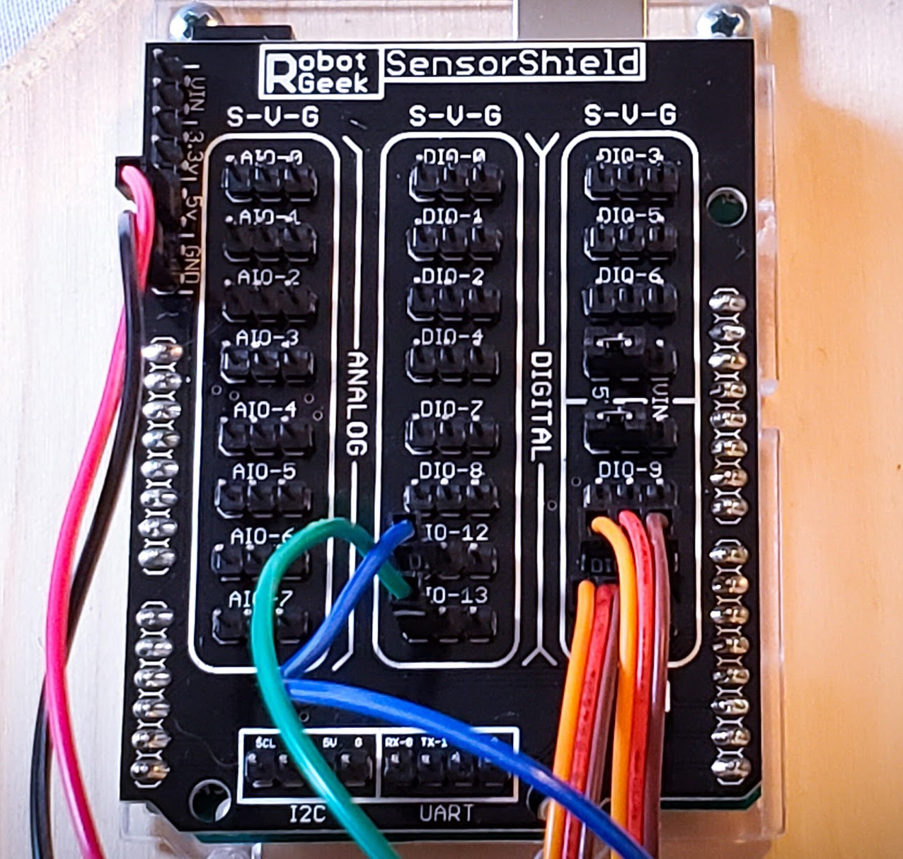
Figure 4.1: Sensor Shield Wiring

The next step is to attach the male ends of the jumper wires to the breadboard. You will need the breadboard, the HC-05 Bluetooth Module, the 1K Ohm ¼ Watt resistor, and the 2.2K Ohm ¼ Watt resistor specified in the parts list for general assembly. The HC-05 Bluetooth Module has six pins designated for State, RX, TX, GND, VCC, and EN. For this project, only RX, TX, GND, and VCC will be used. The Bluetooth Module has an operating voltage of 5V, but only the VCC and GND pins feature breakout boards to limit the voltage down to 3.3V. Therefore, the 1K and 2K resistor will be used to create a voltage divider (as illustrated in Figure 4.2 [7]), to limit the input voltage down to 3.3V for the RX and TX pins so that the Bluetooth Module is not burnt in the process of connecting it to a power source.
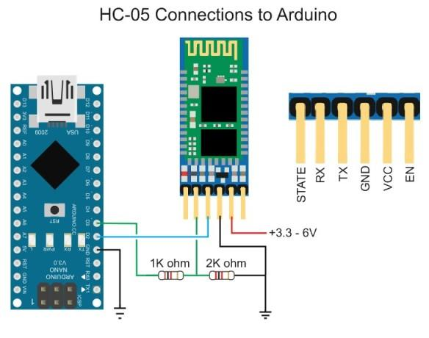
Figure 4.2: Voltage Divider for HC-05

Start by placing the pins of the HC-05 Bluetooth Module into the edge of the breadboard, parallel to the positive and negative power rails. When connecting the male ends of the jumper wires to the breadboard, make sure to connect the green jumper wire (TX) to RX, the blue jumper wire (RX) to TX, the black jumper wire (GND) to GND, and the red jumper wire (5V) to VCC. An illustration of these connections is provided in Figure 4.3. If everything is done correctly, a blinking red LED will indicate that the HC-05 Bluetooth Module is powered up and ready to be paired with a client device.
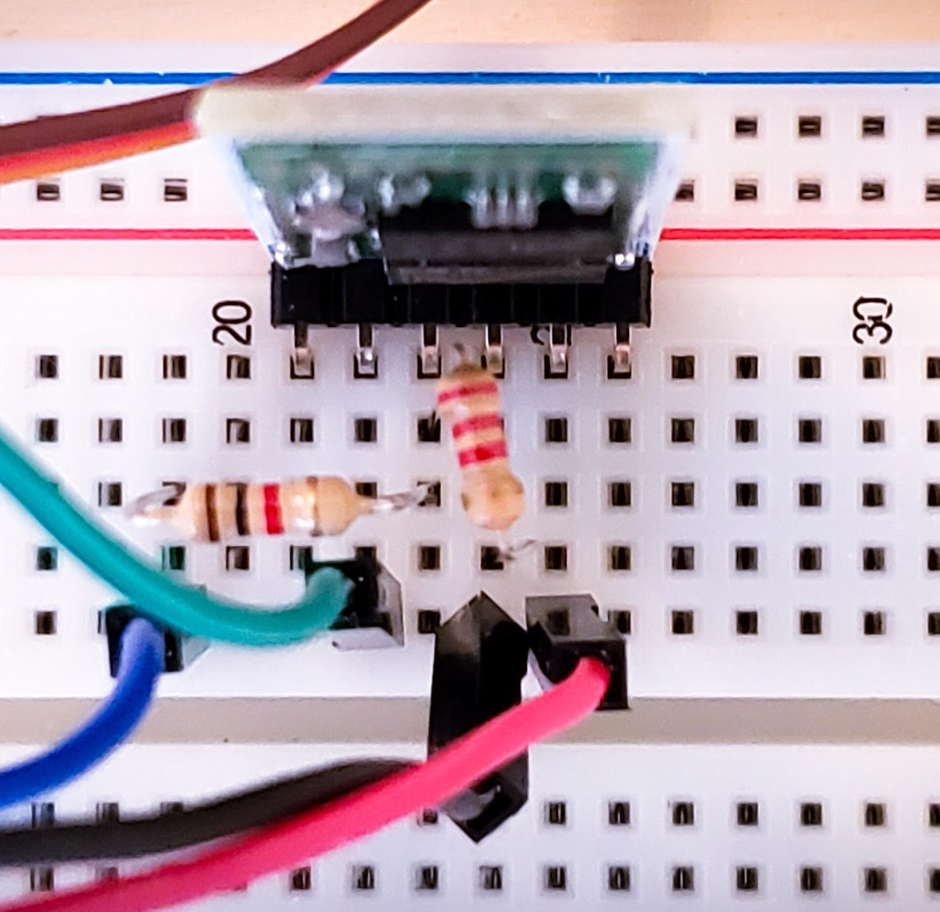
Figure 4.3: HC-05 Bluetooth Module Wiring

The last step of assembly is to mount all of the electrical components to the catapult. The catapult used in this project was a catapult kit manufactured by Rainbow Resource Center that was heavily modified to suit the requirements specification (Figure 4.4), but any catapult that satisfies the following key features will be suitable with this electronics configuration. The first key feature of the catapult includes an axle of rotation, with washers and nuts on either side of the catapult/catapult arm to prevent the axle from swaying back and forth while the catapult is in operation. When adding the axle, make sure that the nuts aren’t tight and don’t create too much friction; otherwise, the catapult arm will not be able to rotate freely. The second key feature is to find ideal mounting points for each of the servos so that servo placement is compatible with the structure of the catapult and is optimal for providing tension to the catapult arm. The final key feature requires two eye bolts: one attached to the rear servo horn and another attached to the catapult arm. A rubber band will be connected to both eye bolts and this will be how the servo provides tension to the catapult arm.
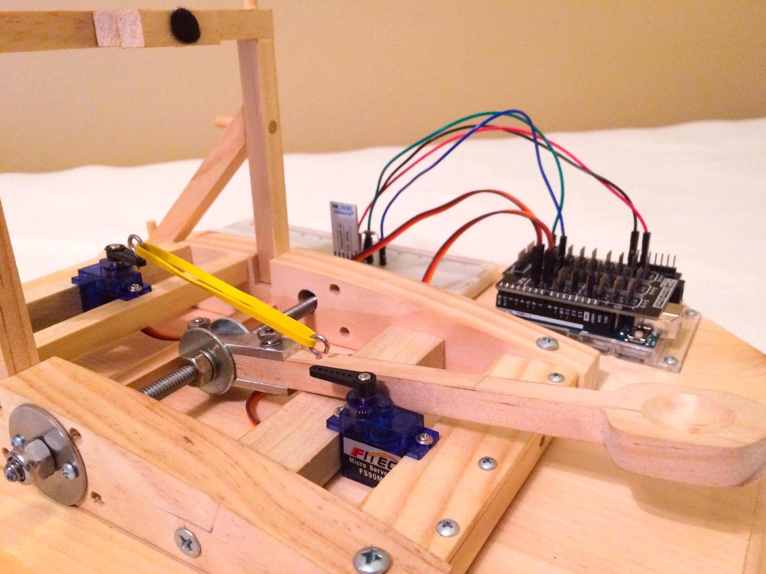
Figure 4.4: Catapult Configuration

To outline how specific elements of the Software Design are converted into code, the Android Software will be examined headmost. As mentioned in the Design Description, the Android Software was built using MIT App Inventor’s GUI designer as well as a concept called blocks, which provides logical back-end functionality to the GUI. Before the back-end composition of the GUI is explored, a brief overview of the construction of the GUI must be provided, since the GUI is what provides input to the back-end. Two non-visible components will need to be imported so that the Android Software may connect to a Bluetooth device and notify the user when the catapult has been armed and launched. Using the GUI design palette, a list viewer designated as ‘Scan’ and a button ‘Disconnect’ will be added to a horizontal arrangement at the top of the viewer. Next, add a text label below ‘Scan’ and ‘Disconnect’ and assign it to another horizontal arrangement. This text label will be used to update the user on the Android device’s connection status, so text contents such as “Connection Status: Disconnected” or similar will be adequate to serve this niche. The text label will be set to disconnected by default because the user will be required to connect to a Bluetooth device before they can operate the catapult. The text label will also be updated when the device is connected and disconnected from a Bluetooth device. The Android logo beneath the connection status label is aesthetic and optional but is also included within the bounds of the horizontal arrangement shared with the text label. Finally, add a button called ‘Arm’ to a horizontal arrangement at the bottom of the GUI design palette. The button text will change between ‘Arm’ and ‘Launch’ for each consecutive button press, to prevent the user from interrupting an event occurrence by initiating another event. The GUI design should follow a similar format to the first screenshot in Figure 4.5. The second screenshot is the list view which is opened when the ‘Scan for Devices’ button is pressed.

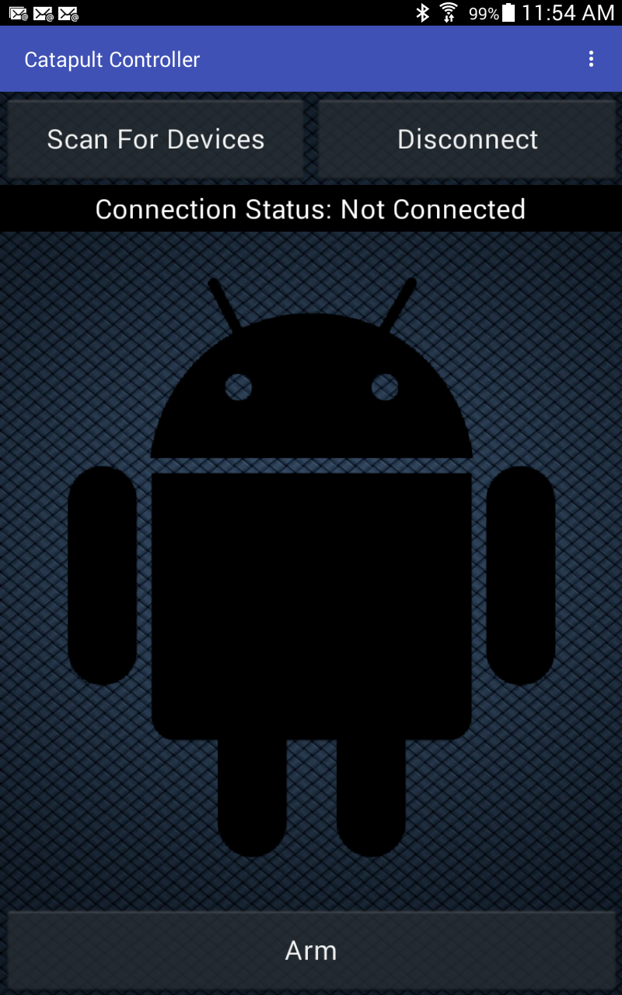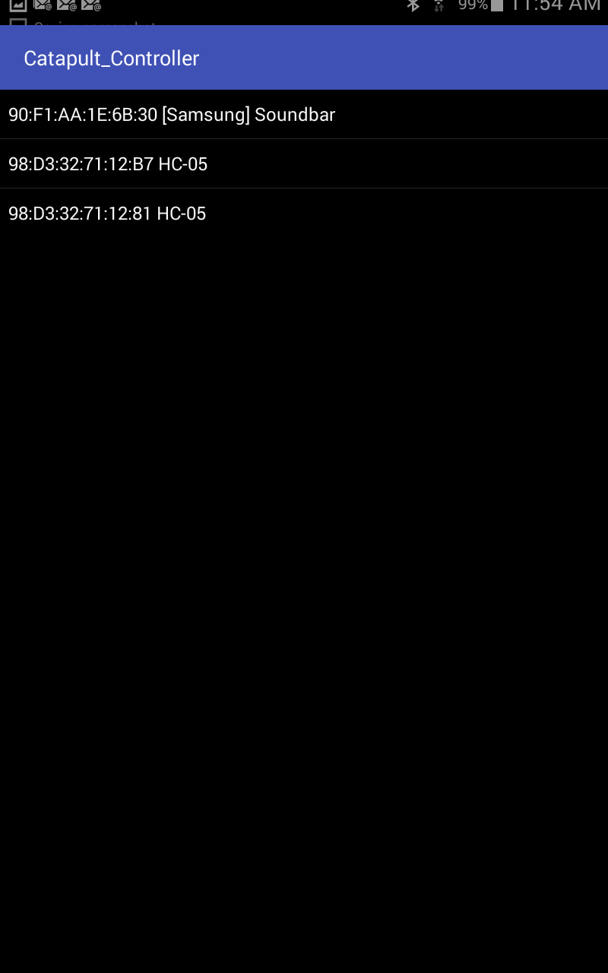
Figure 4.5: Android Software GUI

To delve into the back-end composition of the Android Software, several figures are provided to represent its implementation. For the first control block (Figure 4.6), before picking the ‘Scan’ list viewer, the list viewer is populated with the addresses and names that correspond to all Bluetooth devices in range of the Android device.
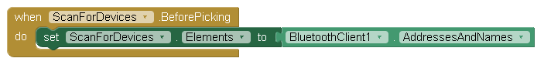
Figure 4.6: Scan List Viewer Implementation (1)

For the second control block (Figure 4.7), after the user has selected a Bluetooth device, the Bluetooth Client will connect the Android device to the address of the Bluetooth device and change the text contents of the status label to “Connection Status: Connected”.
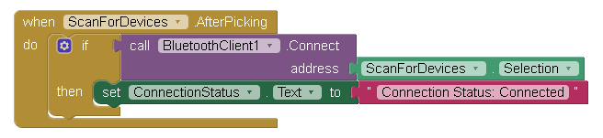
Figure 4.7: Scan List Viewer Implementation (2)

For the third control block (Figure 4.8), a precondition must be satisfied in that the Android device must be connected to a Bluetooth device. When the user presses the ‘Disconnect’ button, the Android Software will disconnect from the Bluetooth Client and alter the text contents of the status label to “Connection Status: Not Connected”.

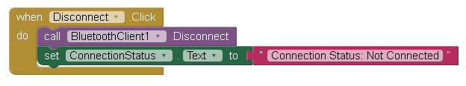
Figure 4.8: Disconnect Button Implementation

For the fourth control block (Figure 4.9), the text contents of the button are initially set to string “Arm” and will only operate provided that the Android device is connected to a Bluetooth device. If the text contents of the button clicked matches the string “Arm”, then the Android Software will send serial data to the Arduino Software in the form of a string “arm”, which will be received as input and stored as a button state. The button will then rename the contents of the text field to string “Launch” and notify the user that “the catapult is armed and ready to launch!” A similar but inverted scenario occurs when the ‘Launch’ button is activated. If the text contents of the button clicked matches the string “Launch”, then the Android Software will send serial data to the Arduino Software in the form of an input string “launch”, reset the contents of the button text field to string “Arm”, and notify the user that “a launch has occurred, re-arm is required!”.
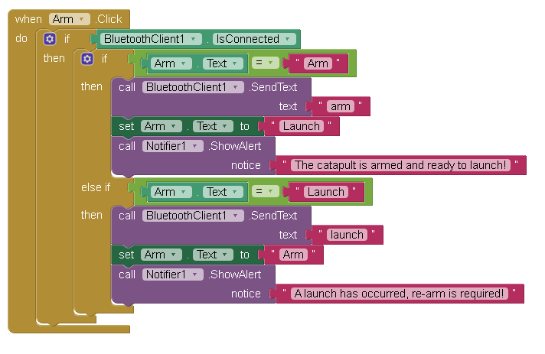
Figure 4.9: Arm/Launch Button Implementation

As far as the Arduino Software there are three main components: setup(), loop(), and actionPerformed(). Each of these functions serve a specific purpose for the functionality of the catapult device. Starting with the setup() function, it will be the first function to run and will only execute once. The setup() function is in charge of establishing the Bluetooth serial connection, defining the corresponding pins (DIO-10 and DIO-11) with the lock and tension servos, and initializing the servo’s position. (Figure 4.10)

// setup code which will only run once
void setup() {
// establish Bluetooth serial connection with baud rate of 9600
btSerial.begin(9600);
Serial.begin(9600);

// attach a pin as a servo driver for lock and tension servos
lock_servo.attach(10);
tension_servo.attach(11);

// set initial position of lock and tension servos
lock_servo.write(90);
tension_servo.write(0);
}

Figure 4.10: Arduino setup() function

Once the setup() function has executed and established a Bluetooth connection, the Arduino Software is ready to function and communicate with the MIT application. The next function to run is the main/loop function, which will run continuously. The loop() function will repeatedly check that the Bluetooth connection is not lost and maintains connection with the Android application via the HC-05 Bluetooth Module. Each iteration of the loop will read input passed to the MIT application in the form of a string: “arm” or “launch”. This input will be received, then passed as a parameter to the actionPerformed() function which will interpret the input. The loop() function is demonstrated in Figure 4.11.

// main code which will be ran repeatedly
void loop() {
if(btSerial.available() > 0) {
while(btSerial.available() > 0) {
button_state = btSerial.readString();
}
actionPerformed(button_state);
}
}

Figure 4.11: Arduino loop() function

The last component of the Arduino Software is the actionPerformed() function. As seen in Figure 4.9, the loop() function receives a string which is forwarded to actionPerformed() via a function call. The string parameter passed will be interpreted by actionPerformed() to perform the desired task of either arming or launching the catapult (Figure 4.12). The Arduino code for interpreting the input uses a simple “if” and” else if” statement to determine the desired action to be performed by the user. The “if” statement compares the input to “arm” which if evaluated to true, will lock and provide tension to the catapult arm via the lock and tension servo. If the “else if” statement evaluates to true, then the user specified the launch sequence. So, the lock servo will be rotated by 90° to release the catapult arm, thus firing the catapult arm. Once the catapult arm has been released/launched, a delay is executed to ensure the catapult arm comes to rest. After the delay of 1000 milliseconds, the tension servo will release the tension on the catapult arm, allowing it to return to a rested position and be ready to be armed again.

void actionPerformed(String button_state) {
// print the string received to serial monitor for debugging
Serial.print("The full string received is: ");
Serial.println(button_state);

// if button state is equal to "arm"
if(button_state == "arm") {
// set the angle of the lock servo to 0 degrees
lock_servo.write(0);
// set the angle of the tension servo to 180 degrees
tension_servo.write(180);
}
// if button state is equal to "launch"
else if(button_state == "launch") {
// set the angle of the lock servo to 90 degrees
lock_servo.write(90);
delay(1000);
// set the angle of the tension servo to 0 degrees
tension_servo.write(0);
}
}
Figure 4.12: Arduino actionPerformed() function

4.2. Testing
Since the structure of the source code for both the Arduino Software and Android Software is relatively primitive, testing was conducted partially using the Arduino IDE’s Serial Monitor (Figure 4.13), which monitors serial data received by the Arduino from the HC-05 Bluetooth Module via a USB to TTL converter. In particular, the Serial Monitor was used to verify that the serial data received by the Arduino corresponded to the output data transmitted over the network by the Android Software. For example, consider Test Cases 1.2 or 1.5, where the user presses the ‘Launch/Arm’ button and the Android Software sends status information to the Arduino Software via serial communication. The Serial Monitor intercepts this serial data as it is received and displays it for testing/debugging purposes. So, for Test Cases 1.2 or 1.5, a series of ASCII characters spelling “launch/arm” will be printed to the Serial Monitor.
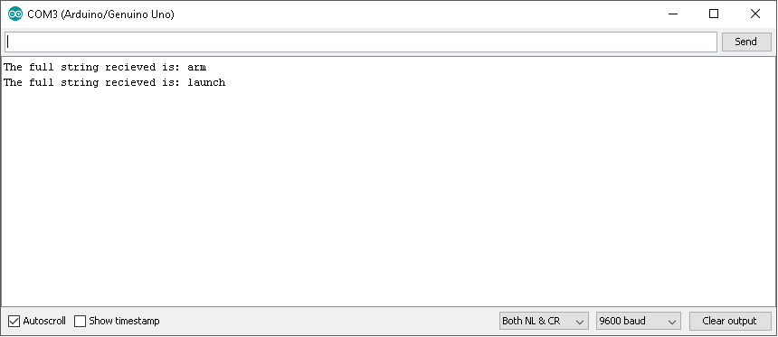
Figure 4.13: Arduino IDE Serial Monitor

For the remaining test cases, the output was determined based on the observed behavior and interactions of the software with respect to the external environment. For instance, consider Test Case 2.1 where the Arduino Software executes a servo.write() command. If the parameter “90” was passed to the servo.write() command, the expected behavior would be for the attached servo to rotate 90° counter-clockwise. A table of all the test cases and their results corresponding to the traceability of the Software Requirements Specification may be found in Figure 4.14.

Test Case # | Input | Output | Successful?
1.1 | The user presses the ‘Launch’ button. | The catapult launches the projectile and the catapult arm freefalls back to the rest position. | The test was successful.
1.2 | The user presses the ‘Launch’ button. | The Serial Monitor displays a series of ASCII characters which spell “launch”. | The test was successful.
1.3 | The user presses the ‘Launch’ button. | The Android Software notifies the user that “the catapult has been launched and is ready to be re-armed!” | The test was successful.
1.4 | The user presses the ‘Arm’ button. | The catapult locks the catapult arm into place and tensions it. | The test was successful.
1.5 | The user presses the ‘Arm’ button. | The Serial Monitor displays a series of ASCII characters which spell “arm”. | The test was successful.
1.6 | The user presses the ‘Arm’ button. | The Android Software notifies the user that “the catapult has been armed and is ready to launch!” | The test was successful.
1.7 | The Android device is disconnected from a Bluetooth device. | The Android Software restricts button operations until the device is connected. | The test was successful.
1.8 | The Android device is disconnected from a Bluetooth device. | The Android Software notifies the user that the connection status is “Not Connected”. | The test was successful.
1.9 | The user presses the ‘Scan’ button. | The Android Software populates a list with local Bluetooth devices that may be connected to. | The test was successful.
1.10 | The Android device is connected to a Bluetooth device. | The Android Software notifies the user that the connection status is “Connected”. | The test was successful.
2.1 | The Arduino Software executes a servo.write() command. | The servo receives a PWM signal and is rotated by a specified interval. | The test was successful.
2.2 | The Arduino Software defines a Servo object for a lock servo and writes to rotate it to 0° and 90°. | The servo locks the catapult arm into place and releases the tension from the catapult arm. | The test was successful.
2.3 | The Arduino Software defines a Servo object for a tension servo and writes to rotate it to 0° and 90°. | The servo adds and removes tension from the catapult arm. | The test was successful.
2.4 | The Arduino Software receives status information in the form of a string named “arm” or “launch”. | The Arduino Software locks the catapult arm into place and tensions the catapult arm, or releases the tension from the catapult arm. | The test was successful.

Figure 4.14: Test Cases
5. Conclusion (TBD)

Overall, the project was successful since it was traceable (satisfied the initial requirements defined in Software Requirements Specification) and passed all test cases with no unexpected behavior or bugs. The project also accomplished its ultimate goal, which was to apply the fundamentals of an embedded system to remotely control a catapult, launching small-scale projectiles via an Android device and fulfilling a need to effectively reduce user intervention, such that the user wouldn’t have to manually retract or lock the catapult arm into place, but would only be required to reload the device.
One of the greatest challenges faced during the course of the project was figuring out what electronic components were compatible with each other, and each of their advantages/disadvantages. For instance, if a Wi-Fi shield had been purchased instead of the HC-05 Bluetooth Module, the RobotGeek Sensor Shield would not have been compatible with the Arduino UNO REV3 microcontroller; therefore, the servos would have had to rely on an external power source (i.e: battery pack) for adequate current and voltage. Also, when prototyping the the breadboard circuit, the advantages and disadvantages of jumper wires as opposed to solid core wire had to be considered. Another challenge faced was debugging the serial data sent from the Android application. Originally, the project utilized Blynk, which is a mobile application that features a GUI builder and allows a device to interface with any IoT configuration. The dilemma with Blynk was that library support for Bluetooth was in the process of development, so it was impractical debugging the application without seeing what was occurring on the back-end. The project eventually migrated into using MIT App Inventor which was also a GUI builder, but unlike Blynk, the back-end was programmable, and it could be debugged from the Arduino IDE’s serial monitor.
If this project was expanded in the future, a mechanism for reloading the catapult, when the ‘Arm’ button is pressed would be added. Also, the catapult could be converted into a motorized vehicle, to allow the catapult to be repositioned autonomously. This way, the catapult would require no manual intervention, but would be operated entirely from a remote device.

6. References

[1] UnusualTravis, Arduino Controlled Catapult, instructables,
URL: https://www.instructables.com/id/Arduino-Controlled-Catapult/

[2] Arduino, ARDUINO UNO REV3,
URL: https://store.arduino.cc/usa/arduino-uno-rev3

[3] MIT App Inventor,
URL: http://appinventor.mit.edu/explore/

[4] RobotGeek, FS90MG Micro Metal Gear Servo,
URL: https://www.robotgeek.com/9g-metal-servo

[5] RobotGeek, Power Supply 6VDC 2.0A - US,
URL: https://www.robotgeek.com/p/power-supply-6vdc-2a.aspx

[6] Velleman, HC-05 Bluetooth Module,
URL: https://www.robotshop.com/en/hc-05-bluetooth-module-velleman.html

[7] StackExchange, Why do you have to use a voltage divider with HC-05 bluetooth module? (Arduino), URL: https://electronics.stackexchange.com/questions/280500/why-do-you-have-to-use-a-voltage-divider-with-hc-05-bluetooth-module-arduino

Appendix A - User Manual

A.1 - Installing the Android Application on a Device
The Catapult Controller application is compatible with any Android device that supports Android Operating System 2.3 ("Gingerbread") or higher. To install the Android application, the .apk file must be downloaded either to a personal computer (PC) or directly to the Android device from the following link: https://github.com/ChristianBedwell/ChristianBedwell.github.io/blob/master/src/CNT%204104%20-%20Software%20Proj%20Comp%20Networks/Catapult_Controller.apk
If the .apk file was downloaded to a PC, then the file must be transferred from the PC to the Android device using a Micro-USB cable. Some older Micro-USB cables are power only and do not allow transfer of files between two machines, so please be aware of this. Make sure that USB storage is disabled on the Android device and also setup the Android to download and install from “Unknown Sources”. To do this, access the Android device settings and navigate to the “General” tab. Then go to “Security” > “Device Administration” and uncheck the checkbox labeled “Unknown Sources”. This is so that the Android device may download .apk files from sources other than the Google Play Store. Now, copy the file from the PC to any folder of choice on the Android device. On the Android device, proceed to the file manager and find the folder in local storage that the .apk file was copied into. Click on the .apk file and the Android device shall prompt for installation of the application, click ‘Install’.

A.2 - Operation of the Android Application
Now that the .apk file has been installed on the Android device, it is ready for operation. The Android application is relatively primitive, with a couple buttons at the top designated for connecting and disconnecting the Android device to the HC-05 Bluetooth Module, whereas the button at the bottom was developed solely for arming and launching the catapult. Note that the Android application will not interface with the catapult until it is connected over the Bluetooth network, so the first step in operating the catapult device is to press the ‘Scan for Devices’ button. This will populate a list with Bluetooth devices and each of their MAC addresses. Select the Bluetooth device called ‘98.D3:32:71:12:B7 HC-05’ to connect to the HC-05 Bluetooth Module. The connection status shall notify that the Android device is ‘Connected’. The Android application interface also provides a means of disconnecting Bluetooth devices, if it is found that the incorrect device was connected or troubleshooting of the Android application is required. Once the device is connected over the Bluetooth network, it may arm or launch the catapult arm using the ‘Arm/Launch’ button. Please note that there may be a brief delay between execution of the button and servo output because the baud rate of the HC-05 Bluetooth Module is set to 9600, so allow adequate time for the servos to move to their designated positions before pressing the button again.

A.3 - Troubleshooting
When connecting to the HC-05 Bluetooth Module, due to the sensitivity of the touch interface on the Android device, it is possible that the incorrect Bluetooth device was selected, that no Bluetooth device was selected at all, or that a Bluetooth device was connected and disconnected simultaneously by accident. It is usually apparent when the incorrect device is selected, because the connection status on the Android device will be ‘Connected’, yet the red LED light on the HC-05 Bluetooth Module will be blinking rapidly (and not at a rate of once every two seconds). If the incorrect device was selected, simply press the ‘Disconnect’ button and ‘Scan for Devices’ once more. If no device was selected or the device was connected and disconnected simultaneously by accident, the connection status on the device will be ‘Not Connected’ and you will also have to ‘Scan for Devices’ again. If the correct Bluetooth device is selected and there is still no connection established with the HC-05 Bluetooth Module, it is recommended to restart the app and reconnect to the HC-05 Bluetooth Module.

Appendix B - Physics Lab Case Study

For the case study of this project, the application of the catapult for educational purposes was explored. Since catapults are ideal subjects for physics lessons on projectile motion, it seemed fitting to reference a physics lab for comparison. The physics lab chosen for comparison was a high school physics lab by the name of the “Trebuchet Project”. Here, the similarities and differences between the catapult and the teachings of the “Trebuchet Project” as well as how the catapult may be applied in a physics lab scenario are examined.

B.1 - Similarities Found in Physics Lab
Since Bluetooth is a short-distance networking technology, this catapult may be used almost anywhere, as long as there is a power source nearby (i.e.: USB to TTL converter, AC power plug). Therefore, considerations of air resistance in calculating the trajectory of the projectile may or may not be negligible. For instance, if the catapult device is operated in an indoors environment, the trajectory does not need to account for wind resistance, so drag would be zero. So, the formula for the trajectory of the catapult projectile (which is equivalent to a parabola) would be as follows:

If wind resistance was taken into consideration, such as in a case where the catapult device is powered using an AC power plug outdoors, then the trajectory path would no longer be a parabola, since the projectile is now subjected to the force of gravity and to deceleration due to wind resistance. In this case, you would use the Euler Method to calculate the projectile motion at each time step Δt:
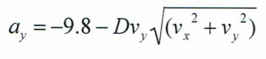
As stated by the Trebuchet Project, “the magnitude of the drag acceleration depends on a complex combination of factors that include: the density of air, the nature of the airflow (smooth or turbulent), the shape of the projectile, the cross-section profile, amd the projectile mass. The projectile used in conjunction with the remotely-controlled catapult is a ping-pong ball, which has a relatively small mass, so air resistance would not be high as say a tennis ball.

B.2 - Differences Found in Physics Lab
Since there is no means of adjusting the launch angle of the projectile or the initial position of the catapult arm, the launch angle and the initial vertical position of the catapult is static with respect to the projectile range. So, these variables would have to me measured by the student and parameterized in the projectile motion formula as constants.

B.3 - Physics Lab Application
Measure the launch angle and initial vertical position of the catapult arm using a protractor. Secondly, measure the time it takes for the projectile to move from its initial x/y position to its final x/y position. This will be your time step Δt. Now split this time step up into six intervals. Calculate the projectile path for each time interval and plot your results. Assume that the drag constant is equivalent to zero (there is no air resistance) for this specific instance of the problem. Now calculate the projectile path, assuming that the drag constant is equivalent to 0.03 m-1 and plot the results. Construct figures from both sets of data and compare your findings from each.

